Network Video Recorder
NVR301E Series
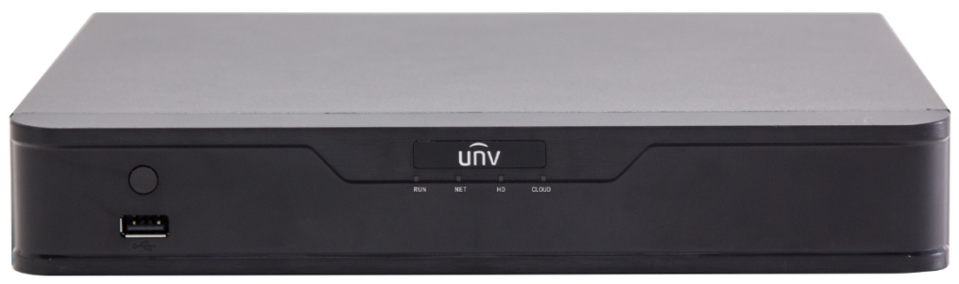

Key Features
- Support Ultra 265/H.265/H.264 video formats
- 4/8/16-channel input
- Third-party IP cameras supported with ONVIF conformance: Profile S, Profile G, Profile T
- Support 1-ch HDMI, 1-ch VGA, HDMI at up to 4K (3840x2160) resolution
- HDMI and VGA simultaneous output
- Up to 8 Megapixels resolution recording
- 1 SATA HDD up to 10 TB
- ANR technology to enhance the storage reliability when the network is disconnected
- Support cloud upgrade

Specifications
Model | NVR301-04E | NVR301-08E | NVR301-16E
Video/Audio Input
IP Video Input | 4-ch | 8-ch | 16-ch
Two-way Audio Input | 1-ch, RCA
Network
Incoming Bandwidth | 40Mbps | 60Mbps | 80Mbps
Outgoing Bandwidth | 64Mbps | 64Mbps | 80Mbps
Remote Users | 128
Protocols | P2P, UPnP, NTP, DHCP, PPPoE
Video/Audio Output
HDMI/VGA Output | HDMI:  4K(3840x2160)/30Hz, 1920x1080p/60Hz, 1920x1080p/50Hz, 1600x1200/60Hz, 1280x1024/60Hz, 1280x720/60Hz, 1024x768/60Hz  VGA:  1920x1080p/60Hz, 1920x1080p/50Hz, 1600x1200/60Hz, 1280x1024/60Hz, 1280x720/60Hz, 1024x768/60Hz
Recording Resolution | 8MP/6MP/5MP/4MP/3MP/1080p/960p/720p/D1/2CIF/CIF
Audio Output | 1-ch, RCA
Synchronous Playback | 4-ch | 8-ch | 16-ch
Corridor Mode Screen | 3/4 | 3/4/5/7/9
Decoding
Decoding format | Ultra 265, H.265, H.264
Live view/Playback | 8MP/6MP/5MP/4MP/3MP/1080p/960p/720p/D1/2CIF/CIF
Capability | 1 x 4K@30, 2 x 4MP@30, 4 x 1080p@30, 8 x 720p@30, 16 x D1
Hard Disk
SATA | 1 SATA interface
Capacity | up to 10TB for each disk
Smart
VCA Detection | Face detection, Intrusion detection, Cross line detection, Audio detection, Defocus detection, Scene change detection, Auto tracking
VCA Search | Face search, Behavior search
Statistical Analysis | People counting
External Interface
Network Interface | 1 RJ-45 10M/100M Self-adaptive Ethernet Interface
USB Interface | Rear panel: 2 x USB2.0, Front panel: 1 x USB2.0
Alarm In | 4-ch
Alarm Out | 1-ch
General
Power Supply | 12V DC  Power Consumption: ≤ 8 W (without HDD)
Working Environment | -10°C~+ 55°C (+14°F~+131°F), Humidity ≤ 90% RH (non-condensing)
Dimensions (W×D×H) | 260mm×240mm×46mm (10.2"×9.4" ×1.8")
Weight (without HDD) | ≤ 1.12Kg (2.47lb)

Dimensions
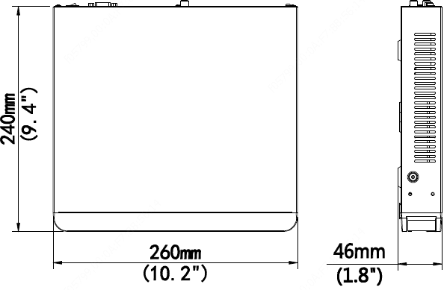

Rear Panel
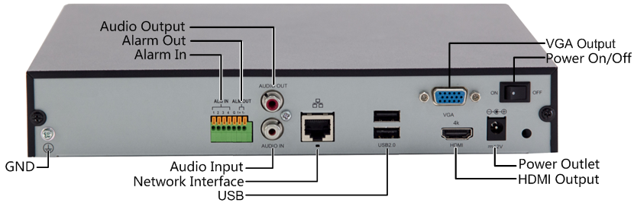
Audio Input
Network Interface
USB
Audio Output
Alarm Out
Alarm In
VGA Output
Power On/Off
Power Outlet
HDMI Output
GND

Zhejiang Uniview Technologies Co., Ltd.
Building No.10, Wanlun Science Park, Jiangling Road 88, Binjiang District, Hangzhou, Zhejiang, China
Email: overseasbusiness@uniview.com; globalsupport@uniview.com
http://www.uniview.com
©2011-2019 Zhejiang Uniview Technologies Co., Ltd. All rights reserved.
- Product specifications and availability are subject to change without notice.

